# Responsive Web Design – Exercise

Problems for exercises and homework for the ["HTML and CSS" course @ SoftUni](https://softuni.bg/courses/html-and-css).

# Topics Covered

*Responsive web design* (RWD) is a web design approach to make web pages render well on all screen sizes and resolutions while ensuring good usability. It is the way to design for a multi-device web. In this article, we'll help you understand some techniques that can be used to master it.

# Resources

* **Responsive design**
  + https://developer.mozilla.org/en-US/docs/Learn/CSS/CSS_layout/Responsive_Design
* **Beginner's guide to media queries**
  + <https://developer.mozilla.org/en-US/docs/Learn/CSS/CSS_layout/Media_queries>

## Simple blog layout

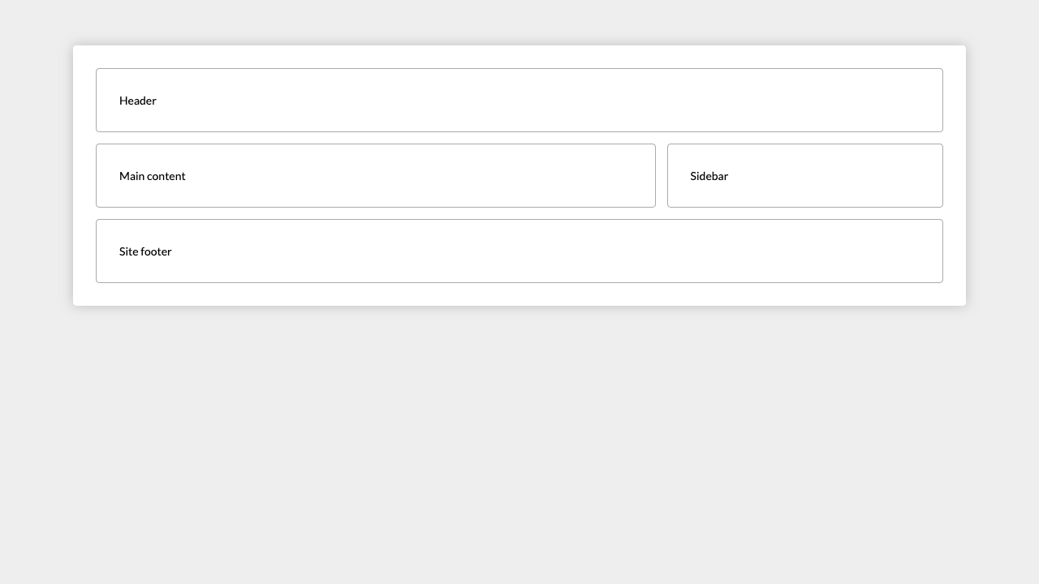

*For full screenshot check the screenshot_[***px].png file in the folder for the task – (there is more than one screenshot)*

**Objective:**

Create a webpage that looks like the screenshot above.

**Requirements:**

1. **File Setup**:
   * Create an HTML document named **simple-blog-layout.html**
   * Create a CSS file named **simple-blog-layout.css**

## Blog layout

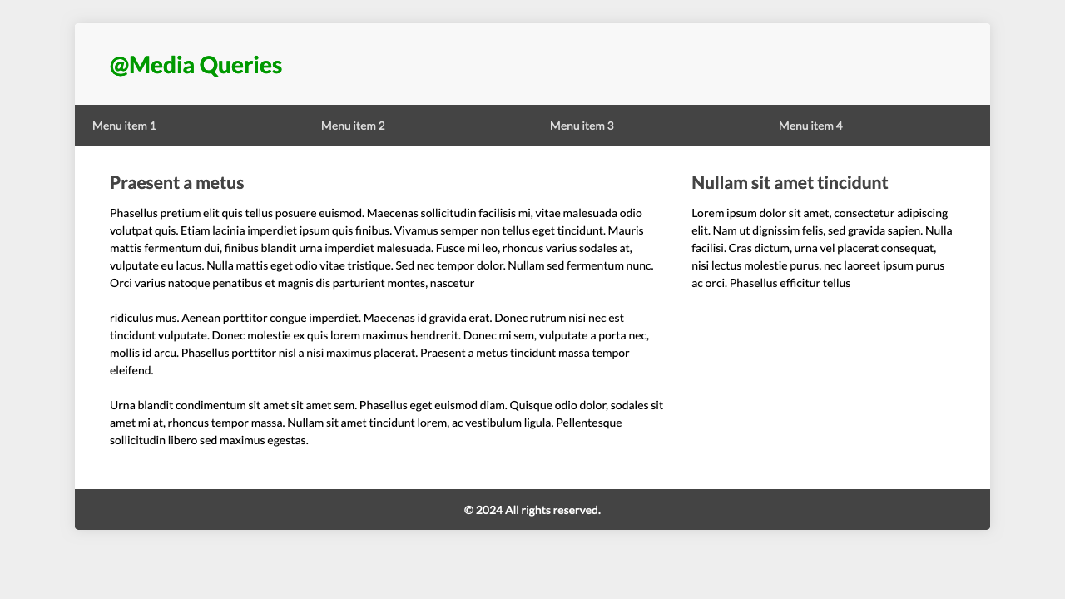

*For full screenshot check the screenshot_[***px].png file in the folder for the task – (there is more than one screenshot)*

**Objective:**

Create a webpage that looks like the screenshot above.

**Requirements:**

1. **File Setup**:
   * Create an HTML document named **blog-layout.html**
   * Create a CSS file named **blog-layout.css**

## Responsive typography

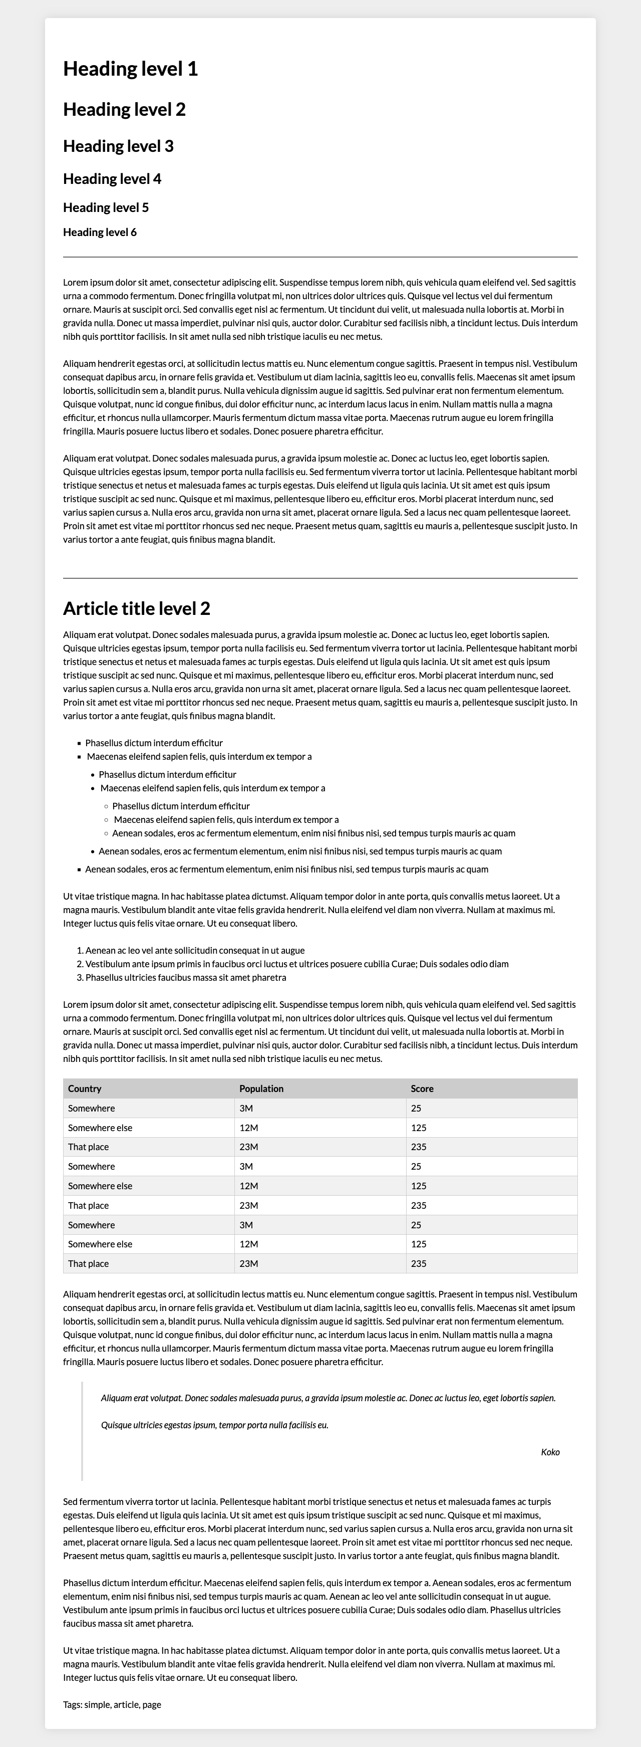

*For full screenshot check the screenshot_[***px].png file in the folder for the task – (there is more than one screenshot)*

**Objective:**

Create a webpage that looks like the screenshot above.

**Requirements:**

1. **File Setup**:
   * Create an HTML document named **responsive-typography.html**
   * Create a CSS file named **responsive-typography.css**

## Responsive tables

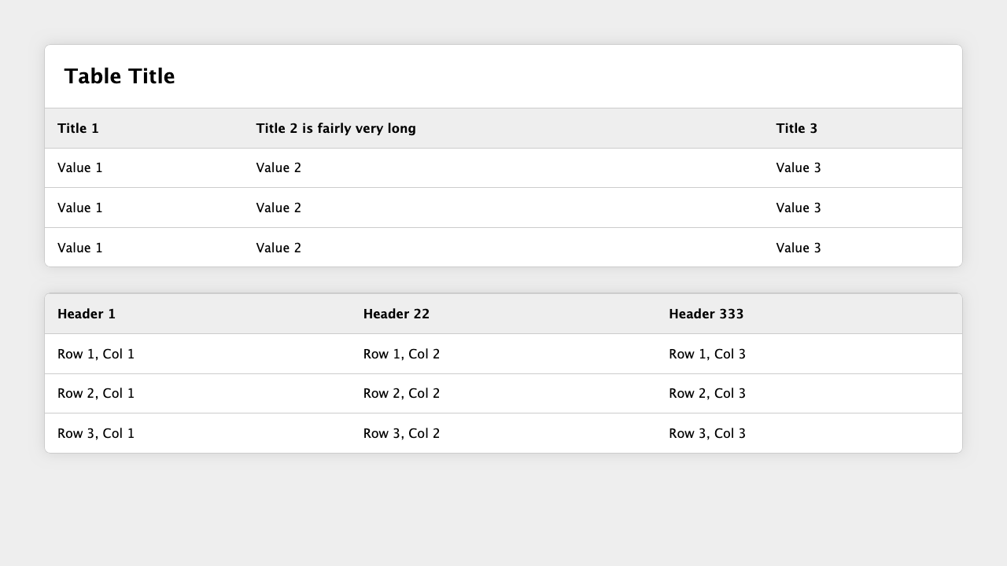

*For full screenshot check the screenshot_[***px].png file in the folder for the task – (there is more than one screenshot)*

**Objective:**

Create a webpage that looks like the screenshot above.

**Requirements:**

1. **File Setup**:
   * Create an HTML document named **responsive-tables.html**
   * Create a CSS file named **responsive-tables.css**
2. **Responsive navigation**

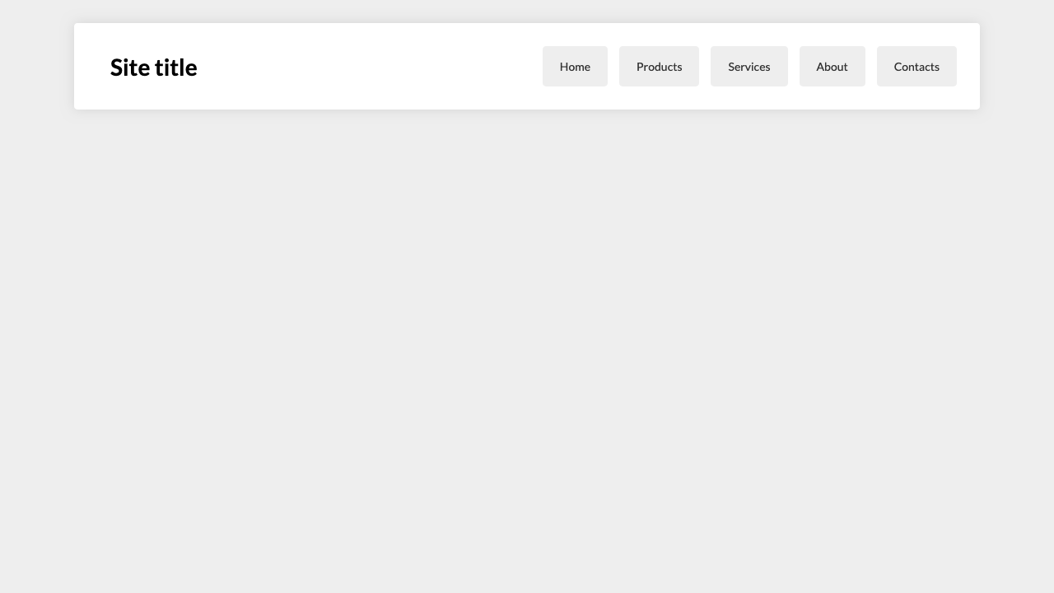

*For full screenshot check the screenshot_[***px].png file in the folder for the task – (there is more than one screenshot)*

**Objective:**

Create a webpage that looks like the screenshot above.

**Requirements:**

1. **File Setup**:
   * Create an HTML document named **responsive-navigation.html**
   * Create a CSS file named **responsive-navigation.css**
2. **Fancy Quotes**

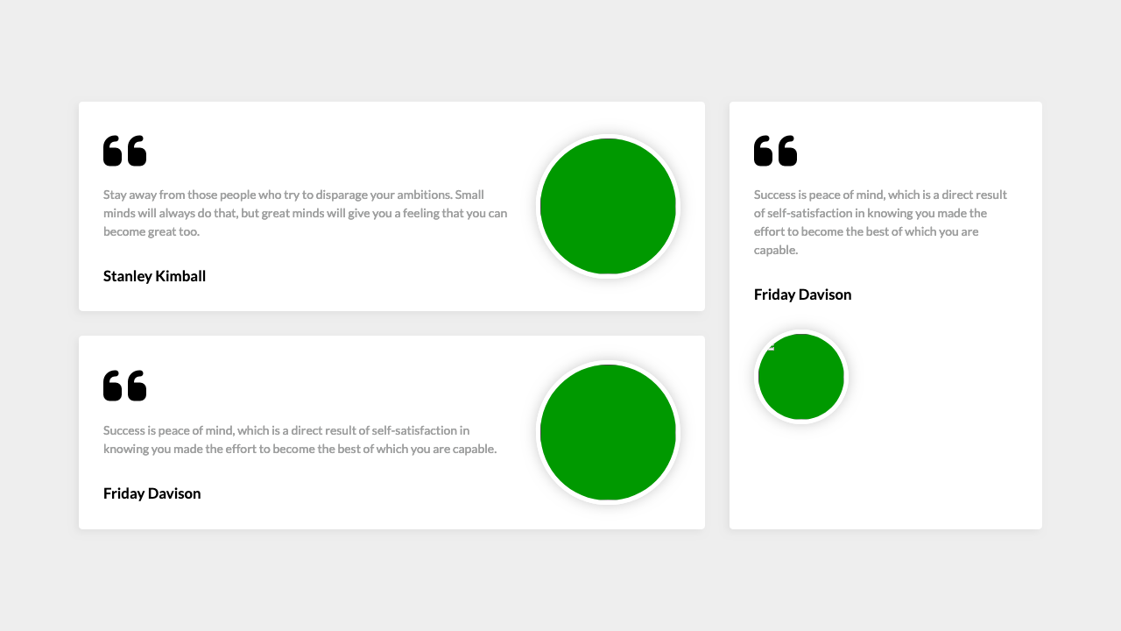

*For full screenshot check the screenshot_[***px].png file in the folder for the task – (there is more than one screenshot)*

**Objective:**

Create a webpage that looks like the screenshot above.

**Requirements:**

1. **File Setup**:
   * Create an HTML document named **fancy-quotes.html**
   * Create a CSS file named **fancy-quotes.css**
2. **Responsive Banner**

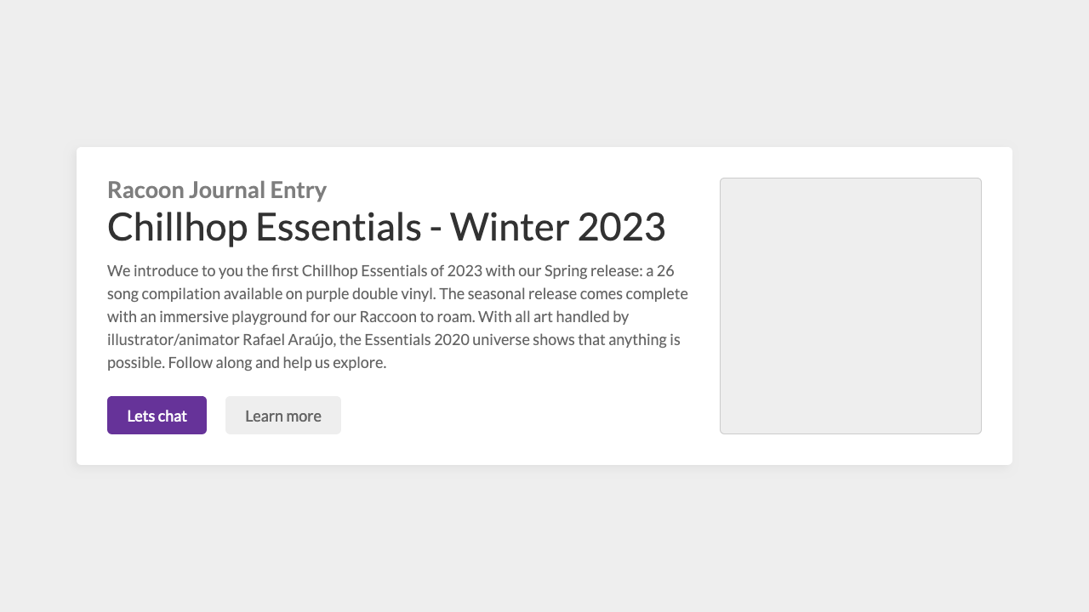

*For full screenshot check the screenshot_[***px].png file in the folder for the task – (there is more than one screenshot)*

**Objective:**

Create a webpage that looks like the screenshot above.

**Requirements:**

1. **File Setup**:
   * Create an HTML document named **responsive-banner.html**
   * Create a CSS file named **responsive-banner.css**
2. **Fancy numbered list**

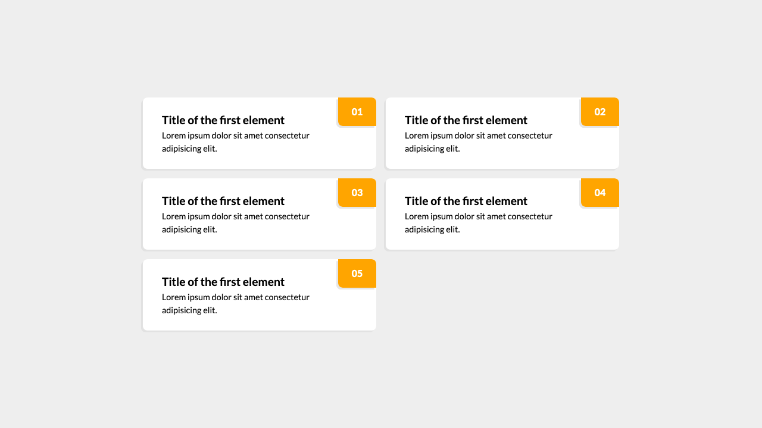

*For full screenshot check the screenshot_[***px].png file in the folder for the task – (there is more than one screenshot)*

**Objective:**

Create a webpage that looks like the screenshot above.

**Requirements:**

1. **File Setup**:
   * Create an HTML document named **fancy-numbered-list.html**
   * Create a CSS file named **fancy-numbered-list.css**
2. **Responsive vertical timeline**

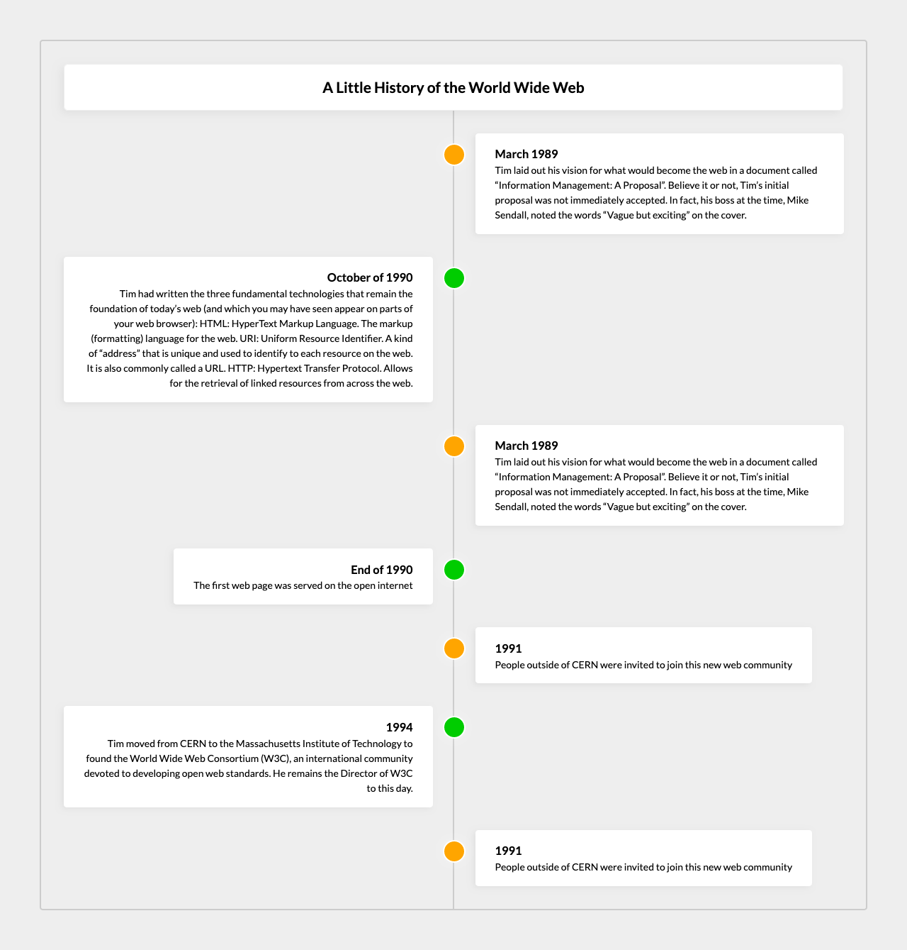

*For full screenshot check the screenshot_[***px].png file in the folder for the task – (there is more than one screenshot)*

**Objective:**

Create a webpage that looks like the screenshot above.

**Requirements:**

1. **File Setup**:
   * Create an HTML document named **responsive-vertical-timeline.html**
   * Create a CSS file named **responsive-vertical-timeline.css**
2. **Cards – Online course**

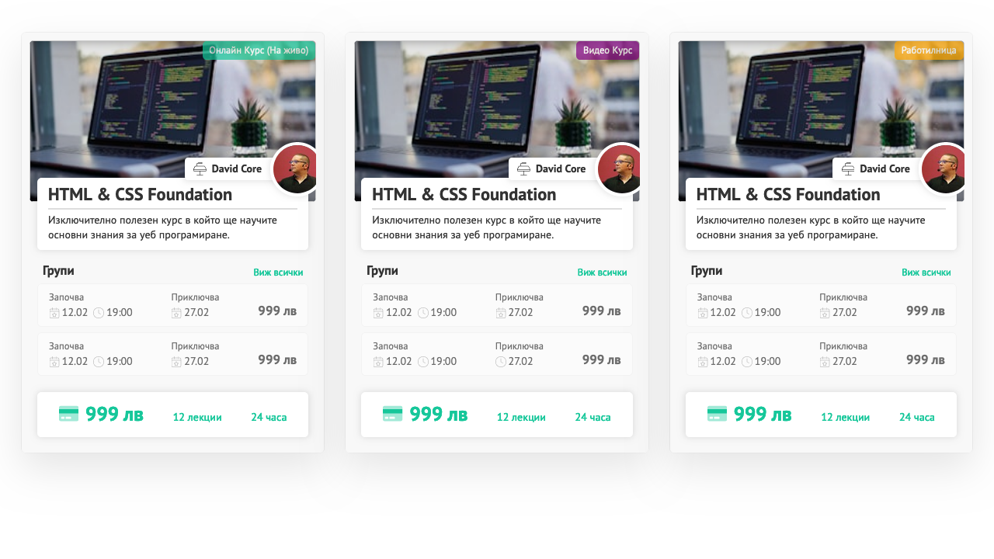

*For full screenshot check the screenshot_[***px].png file in the folder for the task – (there is more than one screenshot)*

**Objective:**

Create a webpage that looks like the screenshot above.

**Requirements:**

1. **File Setup**:
   * Create an HTML document named **card-online-course.html**
   * Create a CSS file named **card-online-course.css**